3. Content Research and Sourcing
3.1 Conducting Research on the Chosen Organisation
Before developing the THAGWIS AI MECHANIC website, I will conduct thorough research to gather accurate and relevant information for each webpage. The purpose of this research is to understand the organisation, identify its target audience, determine the services it intends to provide and collect suitable written and visual content for the website. The research process will help ensure that the website content is relevant, understandable and useful to potential customers.
The website will be planned around five main webpages: Home, About Us, Services, Enquiry and Contact. Each page will require different information depending on its purpose.
Webpage | Content to be researched
Home | Business overview, main services, customer benefits and welcome message
About Us | Company history, mission, vision, values and team information
Services | Detailed descriptions of automotive services and customer benefits
Enquiry | Information required from customers when making a service enquiry
Contact | Contact details, business hours and branch locations
The organisation's information will be presented in a clear and structured way so that visitors can quickly understand the purpose of the business and find the information they need.
Organisation's Website
The first stage of the research will involve checking whether THAGWIS AI MECHANIC has an existing official website. If an official website is available, I will use it as a primary source for factual information such as the organisation's history, services, contact details, operating hours and locations.
Social Media Research
I will also research relevant social-media platforms such as Facebook, Instagram, LinkedIn and TikTok. Social-media research can help me understand how automotive businesses communicate with customers, promote their services and present their brand.

The research will examine areas such as:
- Service promotions
- Vehicle repair projects
- Automotive maintenance tips
- Workshop activities
- Customer engagement
- Diagnostic technology
- Electric-vehicle services
- Promotional campaigns
- The type of visual content used by automotive businesses
Where official THAGWIS AI MECHANIC social-media profiles are unavailable, I will use established automotive businesses' public social-media content only as industry research and inspiration, rather than presenting their information as information belonging to THAGWIS AI MECHANIC.
The information gathered will help me determine what type of content potential customers may expect from an automotive website. The final text will be written originally for THAGWIS AI MECHANIC rather than copied from another organisation.
Public Domain and Creative Commons Resources
The website will require photographs, icons and fonts to create a professional and visually appealing design. I will therefore use reputable websites that provide free or openly licensed resources and will check the applicable licence conditions before using any external material.
I plan to investigate sources such as Unsplash and Pixabay for suitable automotive photographs. Unsplash states that its images can generally be used for personal and commercial projects without requiring permission or attribution, although additional rights may apply to identifiable people, brands, logos and other protected material (Unsplash, 2025).
Pixabay also allows users to use, modify and adapt its content under its Content License, subject to its prohibited-use requirements and any additional rights that may apply to particular content (Pixabay, 2026).

I will therefore search for suitable images relating to:
- Cars and other vehicles
- Automotive workshops
- Mechanics
- Diagnostic equipment
- Car engines
- Electric vehicles
- Vehicle batteries
- Brake systems
- Suspension components
- Automotive technology
I will record the source of each external image selected for the project. This will make it easier to demonstrate where the visual material came from and to verify its permitted use.
Fonts and Icons
I will also research suitable fonts and icons for the website. The typography will need to be professional and easy to read while supporting the automotive and technology-focused identity of THAGWIS AI MECHANIC.
Google Fonts will be considered because Google states that its fonts are released under open-source licences and can be used in both commercial and non-commercial projects (Google, 2026).
I will also investigate suitable open-source icons for areas such as vehicle services, telephone contact, email, locations and customer enquiries. Before using any external icon, I will check its licence requirements.
Original Content Development
A significant amount of the website content will be created specifically for THAGWIS AI MECHANIC. Original content is important because the organisation is being proposed for this academic project and therefore its website needs to communicate a consistent and unique identity.

The original content will include:
- Company introduction
- Company history
- Mission statement
- Vision statement
- Core values
- Team information
- AI vehicle diagnostics description
- Engine repair description
- Electric-vehicle maintenance description
- Brake and suspension repair description
- Battery testing and replacement description
- Fleet maintenance description
- Enquiry instructions
- Contact information
- Business hours
- Calls to action
The proposed Services page will focus on six main service categories:
- AI Vehicle Diagnostics
- Engine Repairs
- Electric Vehicle Maintenance
- Brake and Suspension Repairs
- Battery Testing and Replacement
- Fleet Maintenance
These descriptions will be researched and then written in simple language so that customers without advanced mechanical knowledge can understand what each service involves.

Content Research Strategy
I will follow a structured research process before starting the website development. This will help me avoid adding unnecessary information and ensure that each webpage has a clear purpose.
Research stage | Purpose
Organisation research | Understand the proposed organisation and its objectives
Industry research | Understand automotive services and current industry terminology
Competitor research | Identify useful website-content and presentation practices
Social-media research | Examine customer communication and promotional approaches
Visual research | Identify suitable photographs, icons and other media
Original content creation | Develop unique content for THAGWIS AI MECHANIC
Content review | Check accuracy, relevance, grammar and consistency
The research process will help ensure that the final website is based on relevant information rather than simply filling webpages with text.
Ethical and Copyright Considerations
I will ensure that external content is used responsibly throughout the website-development process. The fact that an image is available online does not automatically mean that it can be copied and reused. I will therefore check the licence conditions of external images, fonts and icons before incorporating them into the website.
For example, although Unsplash provides a broad licence for its images, it explains that trademarks, logos, recognisable people and other protected material depicted in an image may involve additional rights (Unsplash, 2026).
Pixabay similarly explains that some content may be subject to additional intellectual-property, privacy, publicity or trademark rights, meaning that users must consider whether additional permission is required (Pixabay, 2026).
I will therefore preferably select photographs that focus on vehicles, workshops, tools and equipment without unnecessary third-party logos or identifiable individuals.
I will also ensure that original written content is clearly distinguished from researched information. This will help maintain academic integrity and reduce the risk of presenting another organisation's work as my own.
Planned Content Sources Summary
Content type | Planned source | Website page
Business information | Organisation research/project information | Home & About
Company history | Organisation research/original content | About
Automotive services | Industry research & original content | Services
Customer benefits | Original content | Home
Workshop photographs | Unsplash/Pixabay | Home & Services
Team photographs | Approved/licensed resources | About
Branch photographs | Approved/licensed resources | Contact
Contact details | Organisation/project information | Contact
Enquiry instructions | Original content | Enquiry
Calls to action | Original content | Home & Services
Fonts | Google Fonts | All pages
Icons | Open-source/licensed resources | Services & Contact

3.2 Expected Outcome of the Research
At the end of the research stage, I expect to have a complete content plan for each webpage, a record of the sources used, a collection of appropriately licensed visual resources and original written content ready for development. This preparation will make the development process more organised because I will know what information belongs on each page before I begin writing the HTML.
The research will therefore provide the foundation for developing a website that is informative, professional, visually appealing and relevant to the target customers of THAGWIS AI MECHANIC.

4. Website Structure and Planning
4.1 Sitemap
I will use the sitemap to show the planned structure of the THAGWIS AI MECHANIC website before development begins. The sitemap shows the main pages, their relationship with the homepage and the type of content that will appear on each page.
The website will contain five main pages:
- Homepage – index.html
- About Us – about.html
- Services – services.html
- Enquiry – enquiry.html
- Contact – contact.html
All five pages will be connected through the same navigation menu so that a visitor can move from one page to another.

4.1.1 Visual Sitemap
t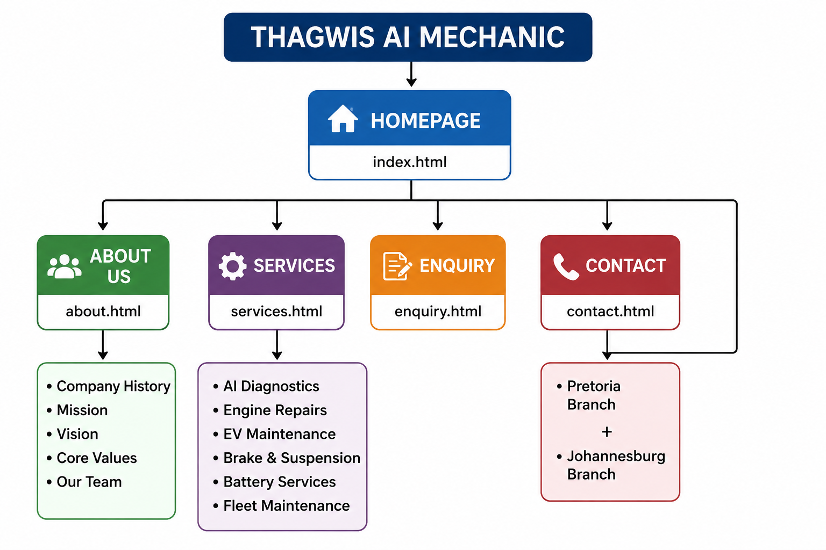

4.1.2 Homepage – index.html
The Homepage will be the main entry point to the website. I will design it to give visitors a quick understanding of what THAGWIS AI MECHANIC does and direct them to the other sections of the website.
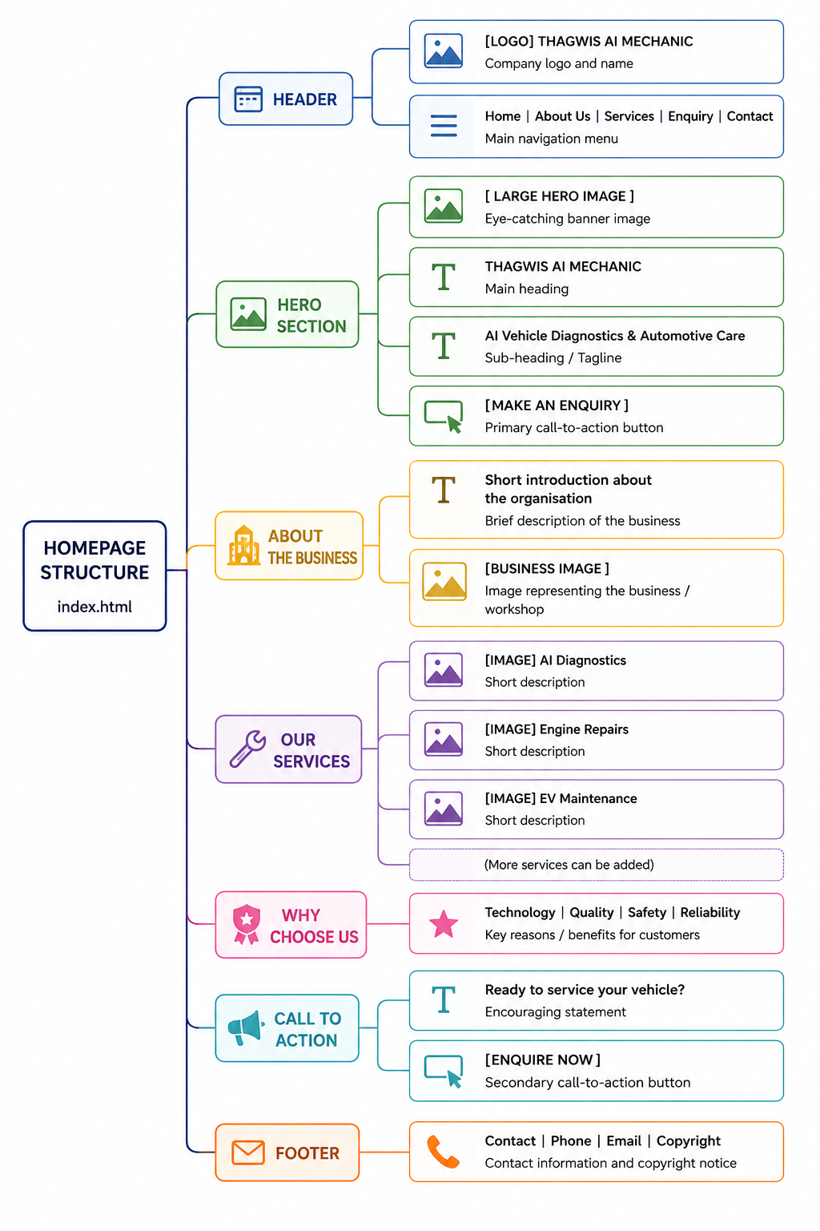

Images planned for the homepage
I will include spaces for:
- Logo – at the top of the page.
- Hero image – a large automotive/technology photograph.
- Business image – a workshop or vehicle image.
- Service images – smaller images representing the main services.

4.1.3 About Us – about.html
The About Us page will introduce the organisation and explain its background and purpose.
┌───────────────────────────────────────────────┐
│ HEADER │
│ [LOGO] THAGWIS AI MECHANIC │
│ Home | About Us | Services | Enquiry | Contact│
├───────────────────────────────────────────────┤
│ ABOUT US │
│ │
│ [ABOUT US IMAGE] │
├───────────────────────────────────────────────┤
│ COMPANY HISTORY
│
│ Text about the organisation
│
├───────────────────────────────────────────────┤
│ OUR MISSION
│
│ Mission statement
│
├───────────────────────────────────────────────┤
│ OUR VISION │
│ │
│ Vision statement │
│ │
├───────────────────────────────────────────────┤
│ CORE VALUES │
│ │
│ Integrity | Innovation | Quality | Safety │
├───────────────────────────────────────────────┤
│ OUR TEAM │
│ │
│ [TEAM IMAGE] │
│ │
│ Manager / Technicians / Support Staff │
├───────────────────────────────────────────────┤
│ FOOTER │
└───────────────────────────────────────────────┘
Images planned for the About Us page
I will provide space for:
- Organisation/workshop photograph
- Team photograph
- Optional photograph of technicians working on vehicles
The images will be positioned close to the information they support.

4.1.4 Services – services.html
The Services page will provide detailed information about the services offered by the proposed organisation.
┌───────────────────────────────────────────────┐
│ HEADER │
│ [LOGO] THAGWIS AI MECHANIC │
│ Home | About Us | Services | Enquiry | Contact│
├───────────────────────────────────────────────┤
│ OUR SERVICES │
│ │
│ [SERVICES BANNER] │
├───────────────────────────────────────────────┤
│ AI VEHICLE DIAGNOSTICS │
│ │
│ [IMAGE] Service description │
│ │
├───────────────────────────────────────────────┤
│ ENGINE REPAIRS │
│ │
│ Service description [IMAGE] │
│ │
├───────────────────────────────────────────────┤
│ ELECTRIC VEHICLE MAINTENANCE │
│ │
│ [IMAGE] Service description │
│ │
├───────────────────────────────────────────────┤
│ BRAKE & SUSPENSION REPAIRS │
│ │
│ Service description [IMAGE] │
│ │
├───────────────────────────────────────────────┤
│ BATTERY SERVICES │
│ │
│ [IMAGE] Service description │
│ │
├───────────────────────────────────────────────┤
│ FLEET MAINTENANCE │
│ │
│ Service description [IMAGE] │
│ │
├───────────────────────────────────────────────┤
│ [MAKE AN ENQUIRY] │
├───────────────────────────────────────────────┤
│ FOOTER │
└───────────────────────────────────────────────┘
services images
I will use a separate relevant image for each major service:
Service | Planned image
AI Vehicle Diagnostics | Diagnostic equipment/vehicle
Engine Repairs | Vehicle engine
EV Maintenance | Electric vehicle
Brake & Suspension | Brake or suspension components
Battery Services | Vehicle battery
Fleet Maintenance | Multiple commercial vehicles
This will make the Services page easier to scan and visually connect each service with its description.

4.1.5 Enquiry – enquiry.html
The Enquiry page will allow potential customers to provide information about themselves and their vehicles.
┌───────────────────────────────────────────────┐
│ HEADER │
│ [LOGO] THAGWIS AI MECHANIC │
│ Home | About Us | Services | Enquiry | Contact│
├───────────────────────────────────────────────┤
│ SERVICE ENQUIRY │
│ │
│ Introduction / instructions │
├───────────────────────────────────────────────┤
│ CUSTOMER INFORMATION │
│ │
│ First Name: __________________ │
│ Surname: ____________________ │
│ Email: ______________________ │
│ Phone: ______________________ │
├───────────────────────────────────────────────┤
│ VEHICLE INFORMATION │
│ │
│ Make: _______________________ │
│ Model: ______________________ │
│ Year: _______________________ │
│ Registration: ________________ │
├───────────────────────────────────────────────┤
│ SERVICE REQUIRED │
│ │
│ Service: [Select Service ▼] │
│ Date: [Select Date] │
├───────────────────────────────────────────────┤
│ ADDITIONAL DETAILS │
│ │
│ [ ] │
│ [ Describe your enquiry ] │
│ [ ] │
├───────────────────────────────────────────────┤
│ [SUBMIT ENQUIRY] [CLEAR FORM] │
├───────────────────────────────────────────────┤
│ FOOTER │
└───────────────────────────────────────────────┘

Images on the Enquiry page
I will include:
- A small automotive banner image at the top.
- The organisation logo in the header.
- No unnecessary images around the form, so that the customer can concentrate on completing the enquiry.

4.1.6 Contact – contact.html
The Contact page will provide customers with contact information and the required two locations.
┌───────────────────────────────────────────────┐
│ HEADER │
│ [LOGO] THAGWIS AI MECHANIC │
│ Home | About Us | Services | Enquiry | Contact│
├───────────────────────────────────────────────┤
│ CONTACT US │
│ │
│ [CONTACT IMAGE] │
├───────────────────────────────────────────────┤
│ CONTACT DETAILS │
│ │
│ Telephone: __________________ │
│ Email: ______________________ │
│ Business Hours: ______________ │
├───────────────────────────────────────────────┤
│ OUR LOCATIONS │
│ │
│ ┌──────────────────┐ ┌──────────────────┐ │
│ │ PRETORIA │ │ JOHANNESBURG │ │
│ │ │ │ │ │
│ │ [MAP/IMAGE] │ │ [MAP/IMAGE] │ │
│ │ │ │ │ │
│ │ Address │ │ Address │ │
│ │ Telephone │ │ Telephone │ │
│ └──────────────────┘ └──────────────────┘ │
├───────────────────────────────────────────────┤
│ SEND US A MESSAGE │
│ │
│ Name: _______________________ │
│ Email: ______________________ │
│ Subject: ____________________ │
│ Message: ____________________ │
│ │
│ [SEND MESSAGE] │
├───────────────────────────────────────────────┤
│ FOOTER │
└───────────────────────────────────────────────┘
Images on the Contact page
I will include:
- Contact/automotive banner image
- Pretoria location map or location photograph
- Johannesburg location map or location photograph
The two locations will be clearly separated so that visitors can easily identify which branch is closest to them.

4.1.7 Common Structure Across All Pages
I will maintain a consistent structure across the entire website.
┌─────────────────────────────┐
│ HEADER │
│ Logo + Organisation Name │
├─────────────────────────────┤
│ NAVIGATION │
│ Home | About | Services ... │
├─────────────────────────────┤
│ │
│ PAGE CONTENT │
│ │
│ Text + Images + Forms │
│ │
├─────────────────────────────┤
│ CALL TO ACTION │
│ Where applicable │
├─────────────────────────────┤
│ FOOTER │
│ Contact | Copyright │
└─────────────────────────────┘
This consistency will make the website easier to navigate because visitors will know where to find the navigation menu and footer regardless of which page they are viewing.

4.1.8 Image Planning
I will plan the images before developing the HTML so that I know exactly where each image will be placed.
Page | Image | Position
Home | Logo | Header
Home | Hero automotive image | Large image below navigation
Home | Workshop image | About/introduction section
Home | Service images | Services section
About | Organisation image | Introduction section
About | Team image | Our Team section
Services | Services banner | Top of page
Services | Diagnostic image | AI Diagnostics section
Services | Engine image | Engine Repairs section
Services | EV image | EV Maintenance section
Services | Brake image | Brake & Suspension section
Services | Battery image | Battery Services section
Services | Fleet image | Fleet Maintenance section
Enquiry | Automotive banner | Top of form
Contact | Contact image | Top of page
Contact | Pretoria map/image | Pretoria location
Contact | Johannesburg map/image | Johannesburg location

Reference list
Google (2026) Google Fonts. Available at: https://developers.google.com/fonts (Accessed: 07 August 2026).
Pixabay (2026) Content License Summary. Available at: https://pixabay.com/service/license-summary/ (Accessed: 07 August 2026).
Pixabay (2026) Frequently Asked Questions. Available at: https://pixabay.com/service/faq/ (Accessed: 07 August 2026).
Pixabay (2024) Terms of Service. Available at: https://pixabay.com/service/terms/ (Accessed: 07 August 2026).
Unsplash (2025) Can I use Unsplash images for personal or commercial projects? Available at: Unsplash Help Center (Accessed: 07 August 2026).
Unsplash (2025) Releases and Trademarks. Available at: Unsplash Help Center (Accessed: 07 August 2026).
Unsplash (2026) What if there is a brand/logo in an image on Unsplash? Available at: Unsplash Help Center (Accessed: 07 August 2026).

